Computer networks

Packet tracker laboratory exam

Allotted time: 1h 30 min

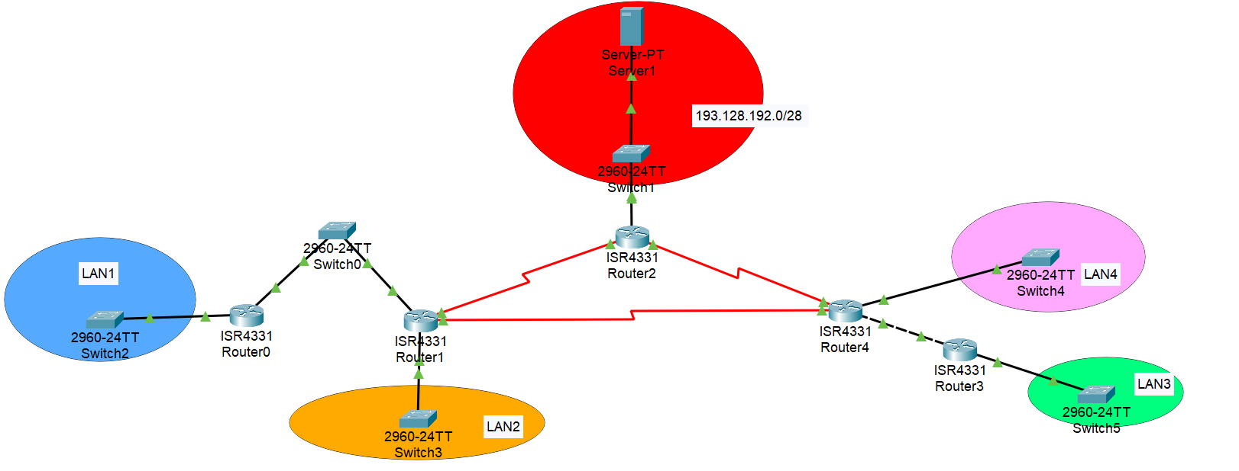

(**3p**) All the IPs from the local area networks (LAN1, LAN2, LAN3 and LAN4) are allocated from the range 179.26.224.0/23. Perform subnetting (using the minimum subnet size) such that:

* LAN1 can store 120 hosts
* LAN2 can store 98 hosts
* LAN3 can store 50 hosts
* LAN4 can store 30 hosts

**For each subnetwork write (in a document or on a piece of paper): the ip address of the network, the network mask, the number of hosts it can store and the broadcast address.**

For the networks connecting the routers should come from the address range 10.10.128.0/26.

(**2p**) Add at least two hosts in each local area network and assign IPs in the following manner: for LAN3 use DHCP and also set the DNS server to the server *Server0.* For the other local area networks use static IP addressing and set *Server0* as the DNS server.

(**1p**) Setup the server *Server 0* to be both a web server and a DNS server. The address of the server should be mapped to the name *cs.ubbcluj.ro*.

(**3p**) Configure routing using routing using RIP v2.

Default: **1p**